**INTRODUCTION TO COMPELX IMPULSES IN MATLAB**

**LAB # 07**



**Spring 2022**

**CSE301L Signals & Systems Lab**

Submitted by: **Ebtihaj Abdullah**

Registration No. : **20PWCSE1885**

Class Section: **A**

“On my honor, as student of University of Engineering and Technology, I have neither given nor received unauthorized assistance on this academic work.”

Student Signature: ______________

Submitted to:

**Engr. Durr-e-Nayab**

Wednesday, June 1, 2022

**Department of Computer Systems Engineering**

**University of Engineering and Technology, Peshawar**

## Lab Objective(s):

Objectives of this Lab are;

* Generating unit impulse and unit step sequences
* Basic signal operations

## Task # 01:

Using ones function; plot the signum sequence over interval ‐10≤n≤10. It can be defined as:

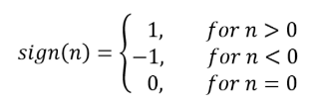

**Problem Analysis:**

Impulse signals are important type of signals in SS.

**Algorithm:**

* Take in the signal parameters
* Plot the signal

**Code:**

a=-ones(1,10);

b=ones(1,10);

signal=[a 0 b];

t=[-10:10];

stem(t,signal);

**Output / Graphs / Plots / Results:**

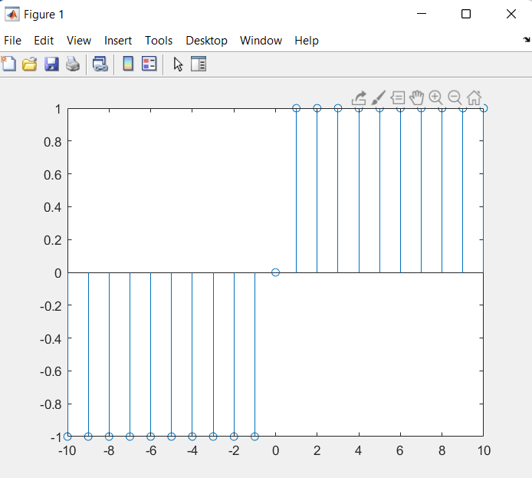

**Discussion and Conclusion:**

We can produce signum sequence in MATLAB.

## Task # 02:

Prove the following:



**Problem Analysis:**

Unit Impulse signal is a difference of unit step and delayed unit step signal. We prove that,

**Algorithm:**

* Take in unit step signal.
* Take in delayed unit step signal.
* Subtract both signals.
* Plot all three (including resultant) signals

**Code:**

*t=-10:10;*

*a=[zeros(1,10),ones(1,11)];*

*b=[zeros(1,11),ones(1,10)];*

*subplot(2,2,1);*

*stem(t,a);*

*subplot(2,2,2);*

*stem(t,b);*

*x=a-b;*

*subplot(2,2,3);*

*stem(t,x);*

**Output / Graphs / Plots / Results:**

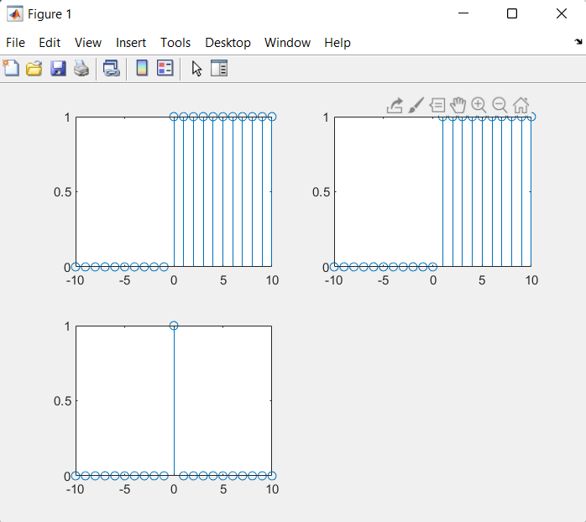

**Discussion and Conclusion:**

Hence L.H.S == R.H.S

## Task # 03:

Delay the original signal given in above example by 1 sec. Plot both the delayed & original signal on the same figure.

**Problem Analysis:**

Delaying a signal is important for certain signal operations.

**Algorithm:**

* Take in the signal
* Delay the signal
* Plot the signal

**Code:**

*clc*

*clear all*

*close all*

*n=0:0.002:4;*

*x=sin(2*pi*1*n);*

*subplot(2,1,1);*

*plot(n,x,'linewidth',2);*

*title('Original Signal');*

*xlabel('Time');`*

*ylabel('Signal Amplitude');*

*axis([-3 4 -1 1])*

*grid;*

*subplot(2,1,2);*

*plot(n+1,x,'linewidth',2);*

*title('Delayed signal');*

*xlabel('Time');*

*ylabel('Signal Amplitude');*

*axis([-3 4 -1 1]);*

*grid;*

**Output / Graphs / Plots / Results:**

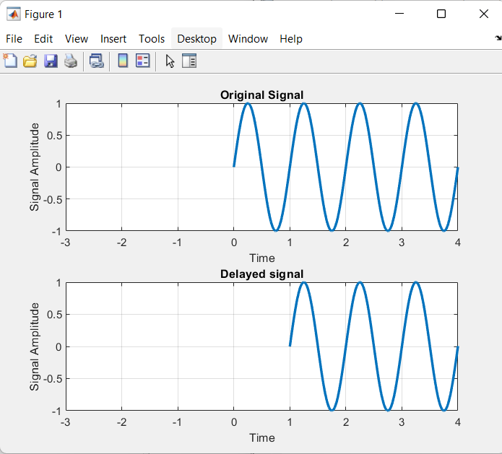

**Discussion and Conclusion:**

Thus we can delay a signal in MATLAB.

## Task # 04:

Flip the following signal:



Plot the original signal as well as the flipped one in the same figure.

**Problem Analysis:**

Signal flipping is sometimes desired in MATLAB.

**Algorithm:**

* Take in the signal
* Flip the signal
* Plot both signals

**Code:**

*clear*

*n=1:1/1000:5;*

*y=5*exp(5*n*pi/4);*

*subplot(2,1,1);*

*plot(n,y, 'g', 'linewidth',2);*

*xlabel('time');*

*ylabel('signal amplitude');*

*title('Original sine wave');*

*grid;*

*subplot(2,1,2);*

*plot(-n,y, 'g', 'linewidth',2);*

*xlabel('time');*

*ylabel('signal amplitude');*

*title('Flipped sine wave');*

*grid;*

**Output / Graphs / Plots / Results:**

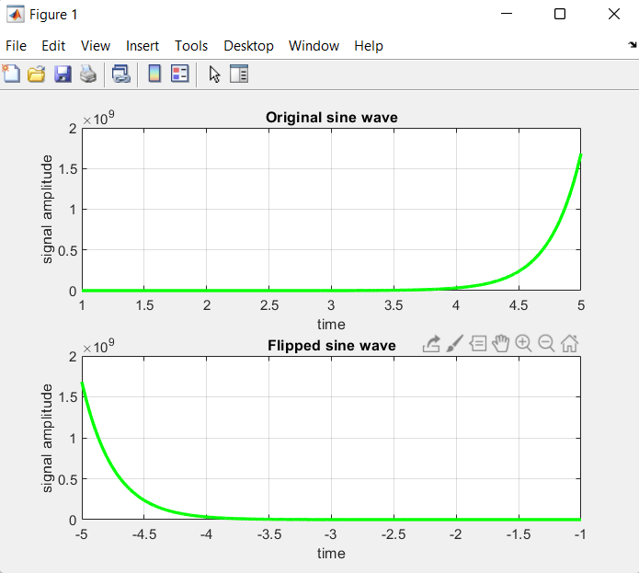

**Discussion and Conclusion:**

Thus we can flip a signal in MATLAB.

## Task # 05:

Flip the following signal:

x[n]= 2δ[n]+ 5δ[n‐1] + 8δ[n‐2] + 4δ[n‐3] + 3δ[n‐4]

Plot the original signal as well as the flipped one in the same figure.

**Problem Analysis:**

Signal inversion or flipping is an important signal operation.

**Algorithm:**

* Take in the original signal.
* Flip the original signal.
* Plot both signals

**Code:**

*n=-10:10;*

*x=[zeros(1,10),ones(1,1),zeros(1,10)];*

*x1=2*x;*

*x=[zeros(1,11),ones(1,1),zeros(1,9)];*

*x2=5*x;*

*x=[zeros(1,12),ones(1,1),zeros(1,8)];*

*x3=8*x;*

*x=[zeros(1,13),ones(1,1),zeros(1,7)];*

*x4=4*x;*

*x=[zeros(1,14),ones(1,1),zeros(1,6)];*

*x5=3*x;*

*x_sum=x1+x2+x3+x4+x5;*

*figure*

*subplot(2,1,1)*

*stem(n,x_sum,'filled')*

*title('Original Signal')*

*subplot(2,1,2)*

*stem(-n,x_sum,'filled')*

*title('Flipped Signal')*

**Output / Graphs / Plots / Results:**

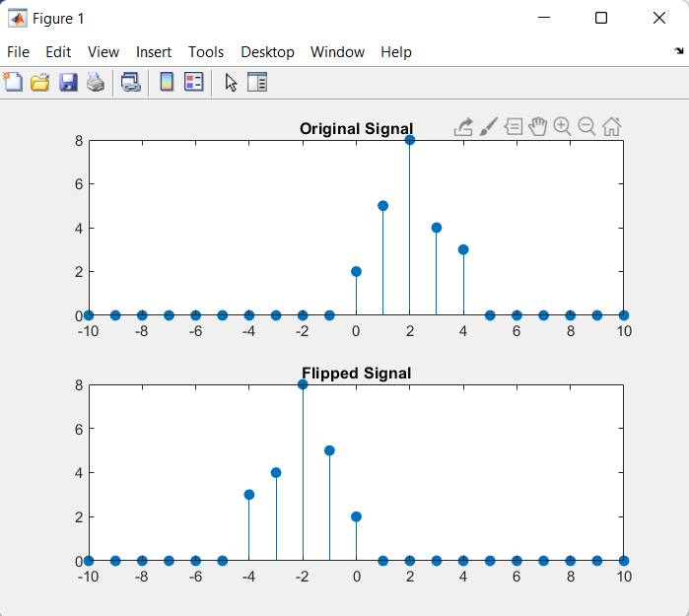

**Discussion and Conclusion:**

Thus we can flip a signal in MATLAB.

## Task # 06:

Scale the continuous‐time sinusoid used in signal shifting example by a factor of 2.

**Problem Analysis:**

Amplitude scaling is necessary for signal operations. Here we perform amplitude scaling

**Algorithm:**

* Takein the original signal.
* Scale its amplitude by 2.
* Plot both signals.

**Code:**

*clear*

*n=1:7;*

*x=[1 2 2 3 2 2 1];*

*subplot(2,1,1);*

*stem(n,x, 'filled');*

*title('Original signal');*

*xlabel('Time index');*

*ylabel('Signal Amplitude');*

*axis([1 7 0 4]);*

*grid;*

*S=2;*

*subplot(2,1,2);*

*stem(n,S*x, 'filled');*

*title('Amplitude Scaled signal');*

*xlabel('Time index');*

*ylabel('Signal Amplitude');*

*axis([1 7 0 8]);*

*grid;*

**Output / Graphs / Plots / Results:**

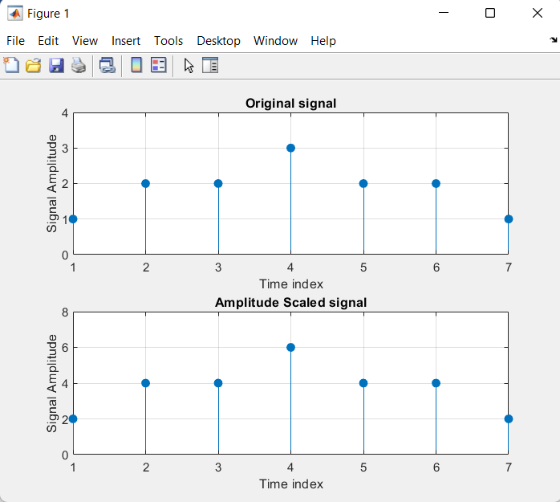

**Discussion and Conclusion:**

Thus we can shift a signal in MATLAB.

## Task # 07:

Use interp command in the above program to interpolate (up‐sample) the signal by a factor of 2.

**Problem Analysis:**

Interpolation is necessary for signal operations. We perform interpolation.

**Algorithm:**

* Take in the signal.
* Interpolate it.
* Plot the signal.

**Code:**

*n=-2:1/1000:2;*

*x1=sin(2*pi*2*n);*

*x2=interp(x1,2);*

*subplot(2,1,1);*

*plot(x1); title('Original signal');*

*xlabel('Sample Number');*

*ylabel('Signal Amplitude');*

*axis([0 4000 -1 1]);*

*grid;*

*subplot(2,1,2);*

*plot(x2);*

*title('Interpolated signal');*

*xlabel('Sample Number');*

*ylabel('Signal Amplitude');*

*axis([0 2000 -1 1]);*

*grid;*

**Output / Graphs / Plots / Results:**

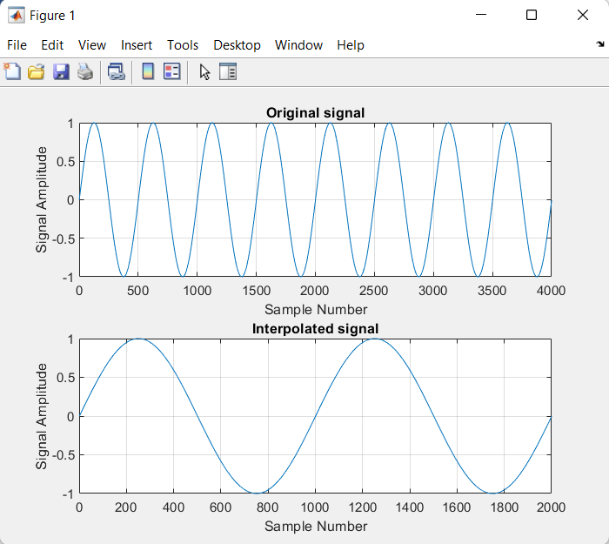

**Discussion and Conclusion:**

Thus we can interpolate a signal in MATLAB.